UI DESIGN WALKTHROUGH
EPC-Intel
How the product looks and how we'll present it on stage
Companion to Implementation_Guide_v2 — six core screens, Rev. 2 scope

Design Direction
The product needs to read as an engineering instrument a QA engineer would trust with a Critical safety finding — not a generic SaaS dashboard. Everything below was chosen against that brief specifically.
Palette
Ink Navy | Steel | Signal Blue | Amber | Red | Green | Slate
Typography
IBM Plex Sans for the interface — a typeface with engineering/technical-documentation heritage, deliberately not the generic Inter/system-font default. IBM Plex Mono for anything precise: clause codes, IDs, timestamps, coordinates — reinforcing 'this number is exact' every time it appears.
Signature element — the twin-track verification indicator
The one idea the judge panel called out as genuinely differentiating was the dual-layer compliance check — an LLM semantic comparison and a deterministic rule engine running in parallel, with the rule engine winning ties. That idea now has a visual signature: two small lane indicators (AI · Rule) shown side by side on every finding, so the product's core defensibility argument is visible at a glance, not just written in a spec document. It appears on the dashboard, the compliance review screen, and nowhere else — spent once, deliberately, rather than diluted across the whole UI.
Honesty pattern — the Simulated banner
Three of the six screens are mockup-tier per the Rev. 2 scope decision (Schedule Risk, Supply Chain, Commissioning). Rather than hide that, every mockup-tier screen opens with a dashed amber banner stating plainly what's real (schema, model, UI) and what's precomputed. This is a product-design decision, not just a disclaimer — it is the same honesty the Rev. 2 guide asked the team to build into the API response schema itself (§4.9, `simulated: true`).
What follows
Six full-resolution screens: Dashboard, Compliance Review (Priority 1), Drawing/P&ID Clearance Check (the new CV slice), RFI Knowledge Chat (Priority 2), Schedule Risk (mockup tier), and Supply Chain (mockup tier). Each page states what to say about that screen on stage.

1 — Dashboard
LIVE MODULES
One project overview combining live findings (Compliance, Drawing Check, RFI) with clearly separated simulated widgets — the first thing a judge sees, and the first proof the honesty pattern is real.
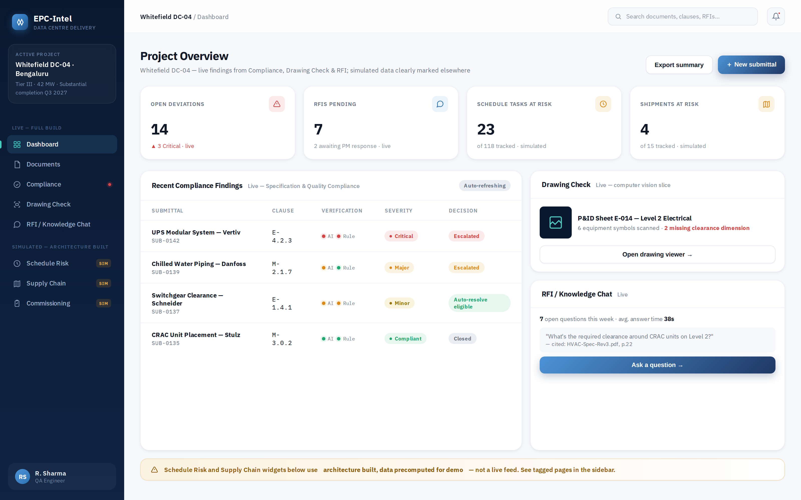
On stage, say:
- "Everything above the amber banner is live — computed from documents we ingested this morning, not seeded."
- "Notice the twin-track indicator on each compliance row — that's the AI check and the rule-engine check, shown side by side, before either one gets to declare a verdict alone."
- "The Drawing Check card is the new computer-vision slice the panel asked for — one click takes you to the actual flagged P&ID."

2 — Compliance Review & Decision Trace
LIVE — PRIORITY 1
The clause-by-clause verification table plus the decision-trace panel — this is the screen that answers Judge Question 1 ('walk us through the actual autonomy loop') directly, live, in the UI.
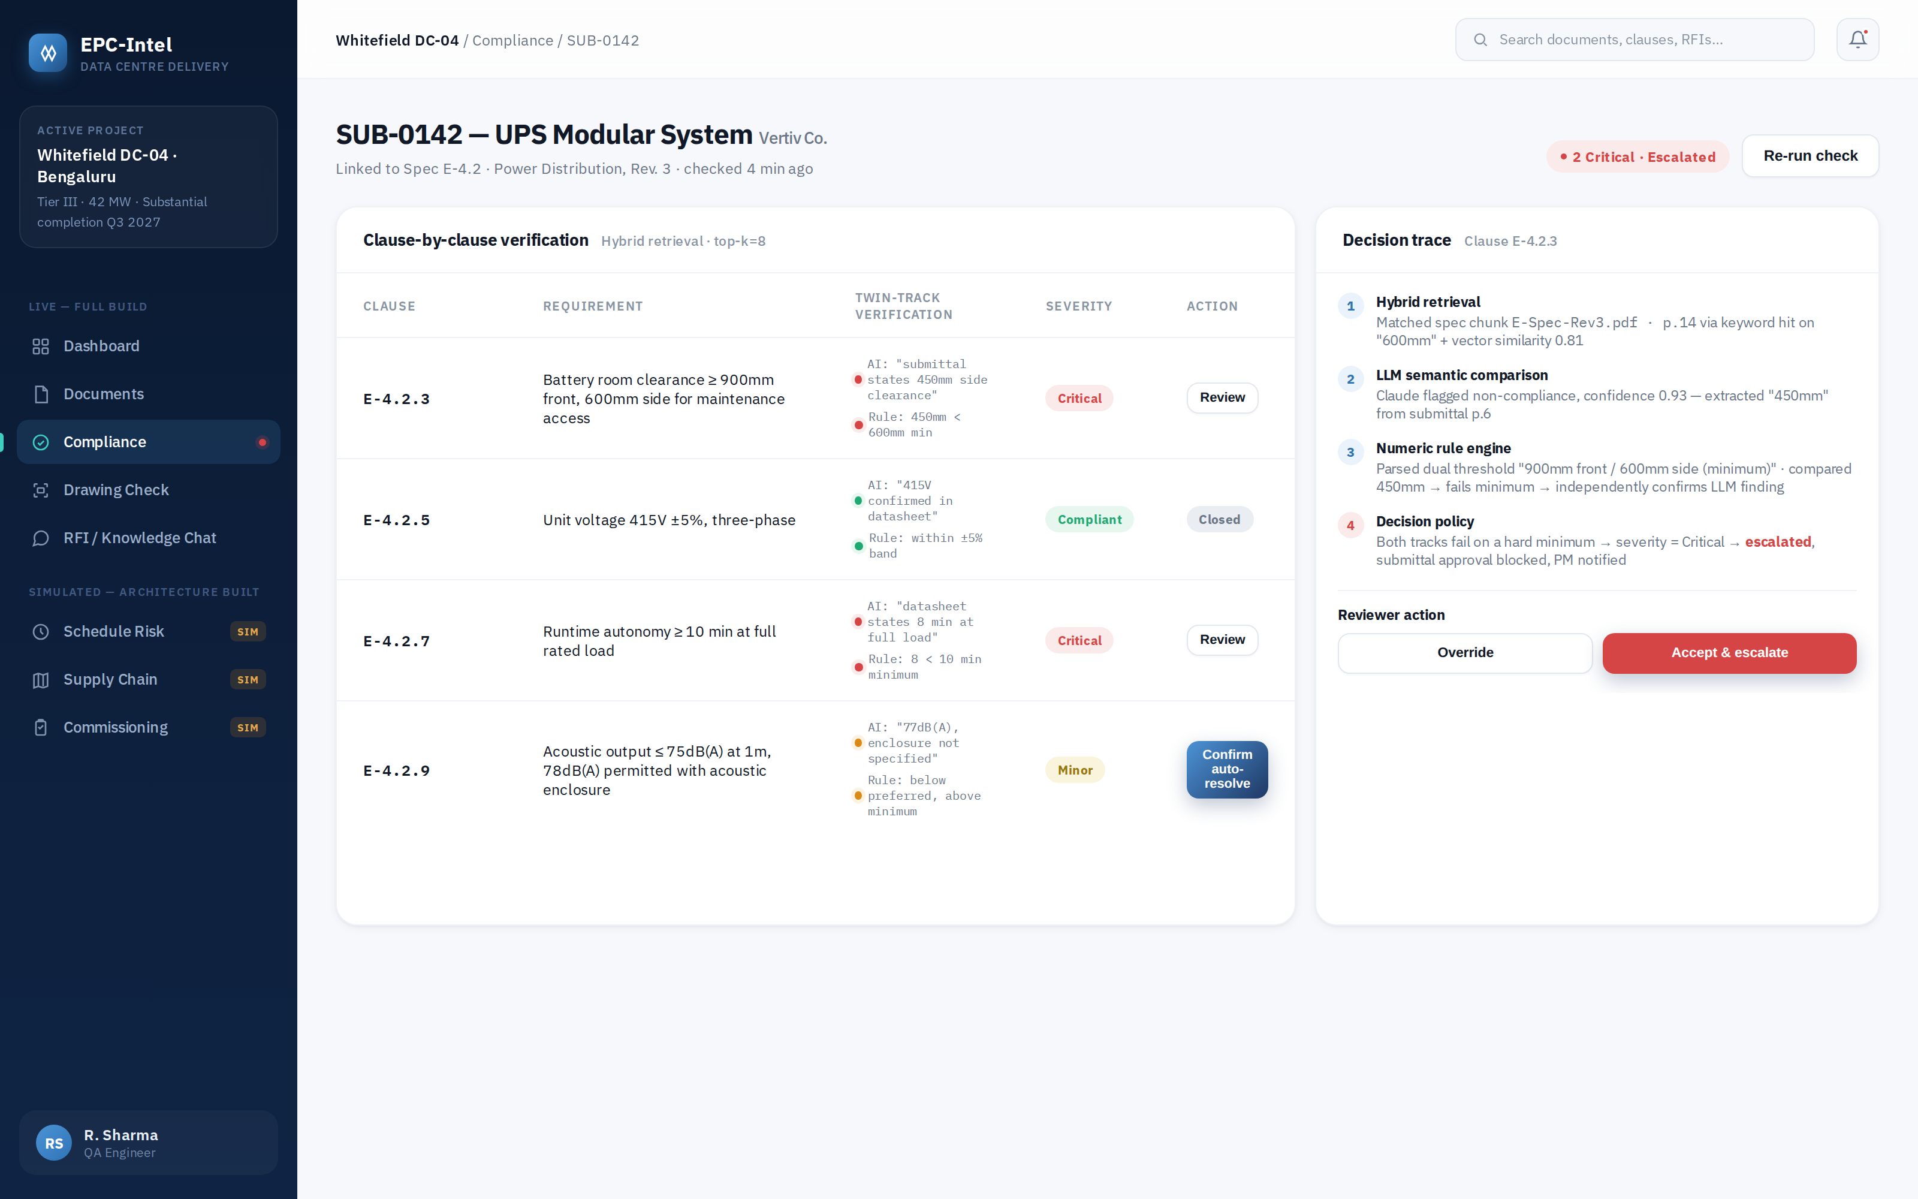
On stage, say:
- "This is the module we're comfortable calling agentic — watch the decision trace: retrieval, LLM comparison, rule engine, then the decision policy actually chooses escalate, auto-resolve, or re-check. That's a visible planning step, not a single model call."
- "Clause E-4.2.3 — both tracks failed independently against a hard minimum, so it's Critical and blocked automatically. Clause E-4.2.9 is a compound requirement — below preferred but above minimum — so it's Minor and eligible for one-click auto-resolve."
- "Every override on this screen writes to an audit log — that's the answer to the liability question before anyone asks it."

3 — Drawing / P&ID Clearance Check
LIVE — CV SLICE
The single highest-leverage addition from the review: a real, scoped computer-vision check on one P&ID sheet, flagging equipment symbols with no adjacent clearance dimension.
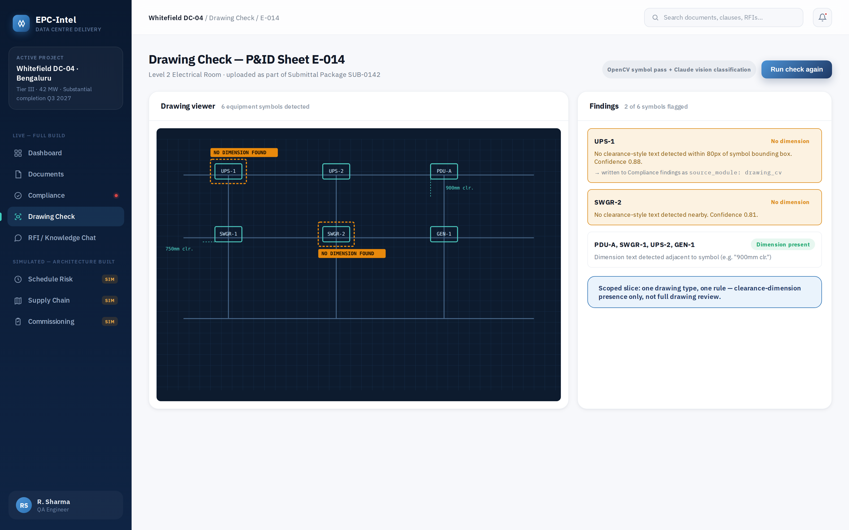
On stage, say:
- "This is deliberately narrow — one drawing type, one rule — because that's what four developers can make real, not aspirational, in 48 hours."
- "Under the hood: OpenCV finds the equipment-symbol regions, Claude's vision model checks whether dimension text sits nearby. No trained detector, because we don't have a labelled P&ID dataset — and we're not pretending otherwise."
- "These findings land in the exact same table as the Compliance findings — one unified findings list across text and drawings."

4 — RFI / Knowledge Chat
LIVE — PRIORITY 2
Cited, hybrid-retrieval Q&A over the ingested corpus, including an honest refusal below the tuned confidence threshold and a superseded-clause example.
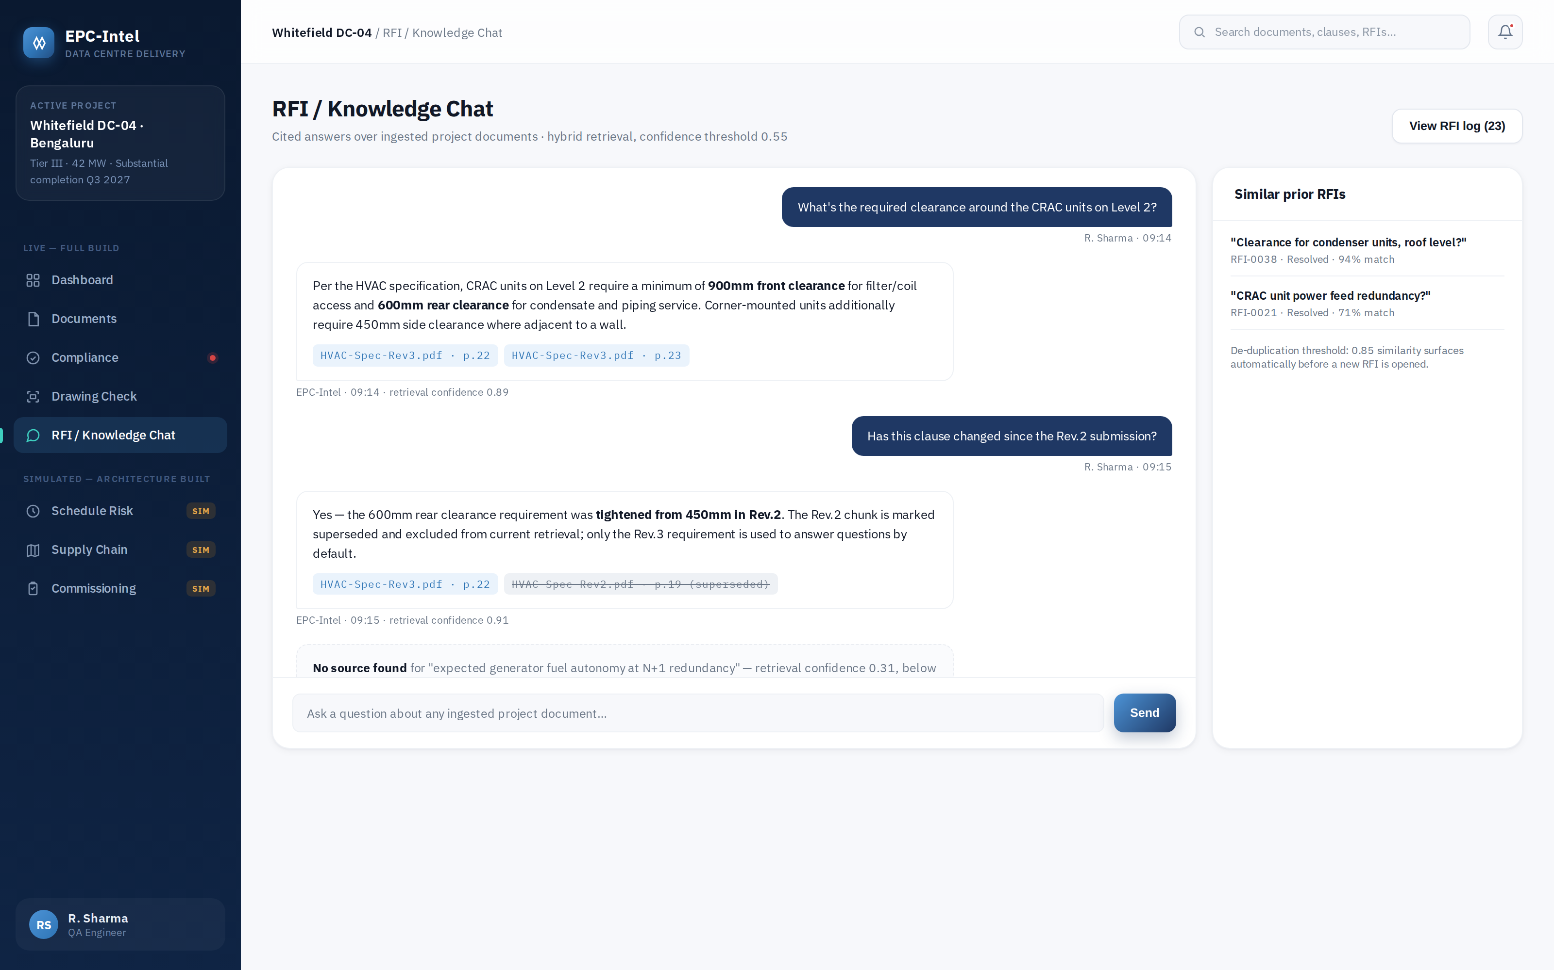
On stage, say:
- "Every citation chip is validated against a chunk we actually retrieved before it's allowed to render — the model cannot cite something it didn't see."
- "Ask it something with no good source and it says so, at a threshold we tuned against the eval set — 0.55 — instead of guessing."
- "The Rev.2 vs Rev.3 example is the document-versioning fix — a superseded clause is labelled superseded, not silently served as current."

5 — Schedule Risk Board
SIMULATED — ARCHITECTURE BUILT
Real schema and a real trained LightGBM model, shown against a mandatory logistic-regression baseline — scored offline, read live in the UI.
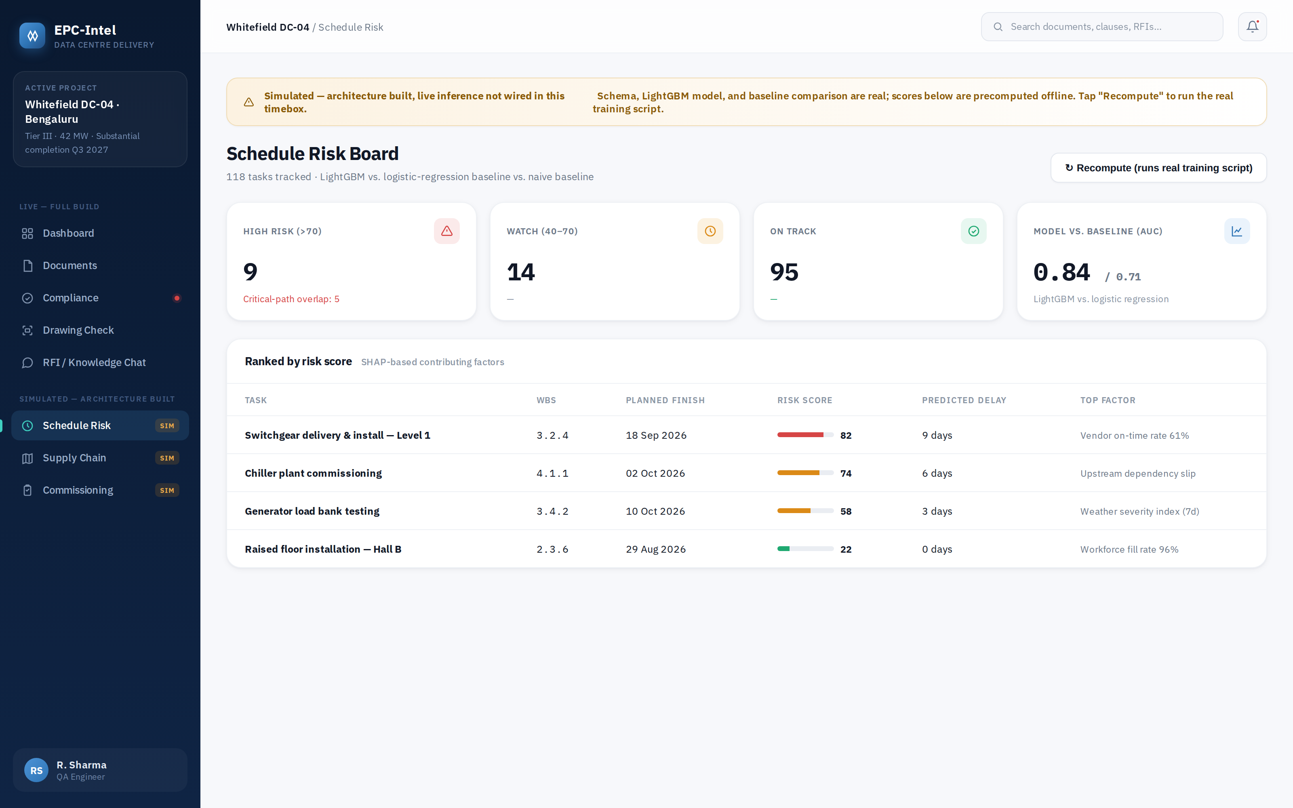
On stage, say:
- "We're not hiding that this is precomputed — the banner says so, and the API response itself carries a simulated flag, not just this label."
- "What is real: the feature pipeline, the trained model, and — the thing the panel specifically asked for — a side-by-side AUC against a plain logistic-regression baseline, 0.84 versus 0.71, so 'LightGBM is better' is a measured claim, not an assumption."

6 — Supply Chain Visibility
SIMULATED — ARCHITECTURE BUILT
Real PostGIS-backed schema and map UI over seeded sample shipments, with a rule-based (not ML — deliberately) risk score.
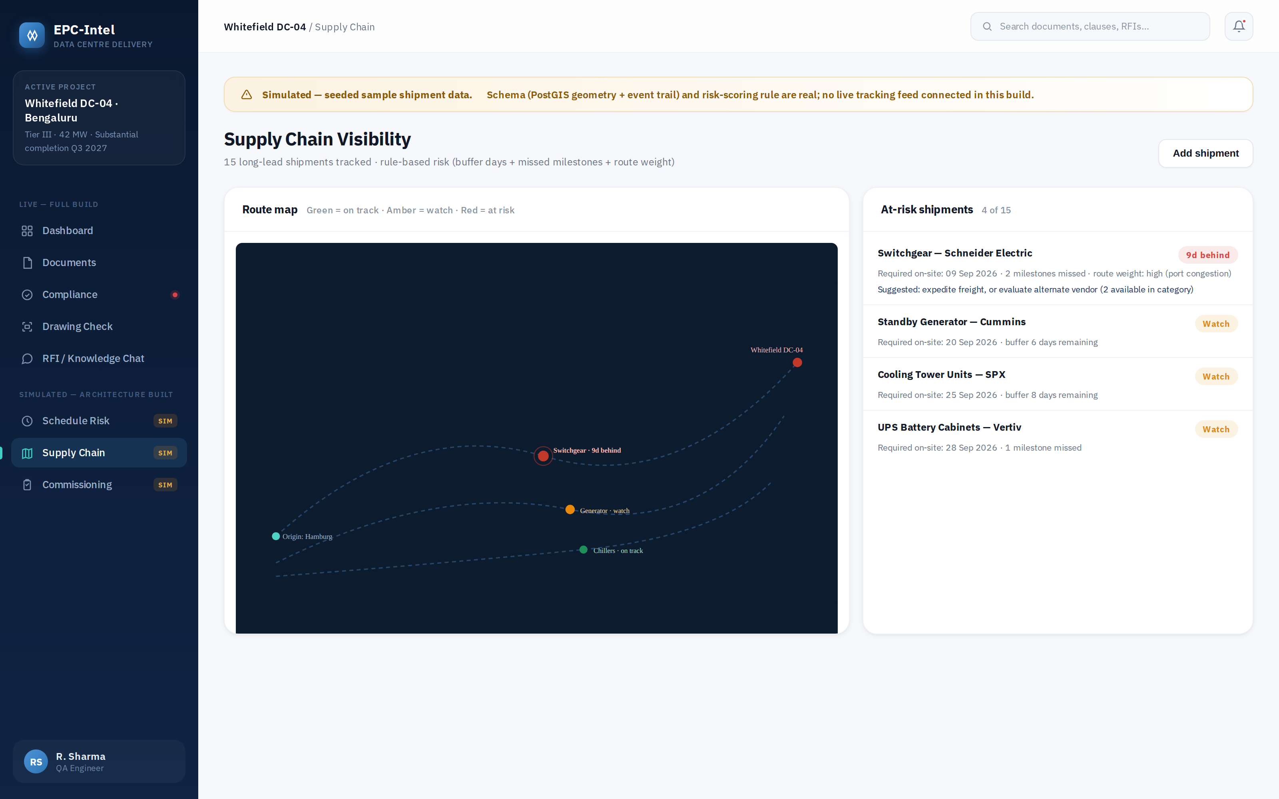
On stage, say:
- "No live tracking feed in this build — seeded milestone data, disclosed exactly the same way as the schedule board."
- "Risk scoring here is intentionally rule-based, not a model — buffer days, missed milestones, route weight. That was true in v1 and it's still the right call; not every problem needs AI."

